Output screenshots

User Story 1
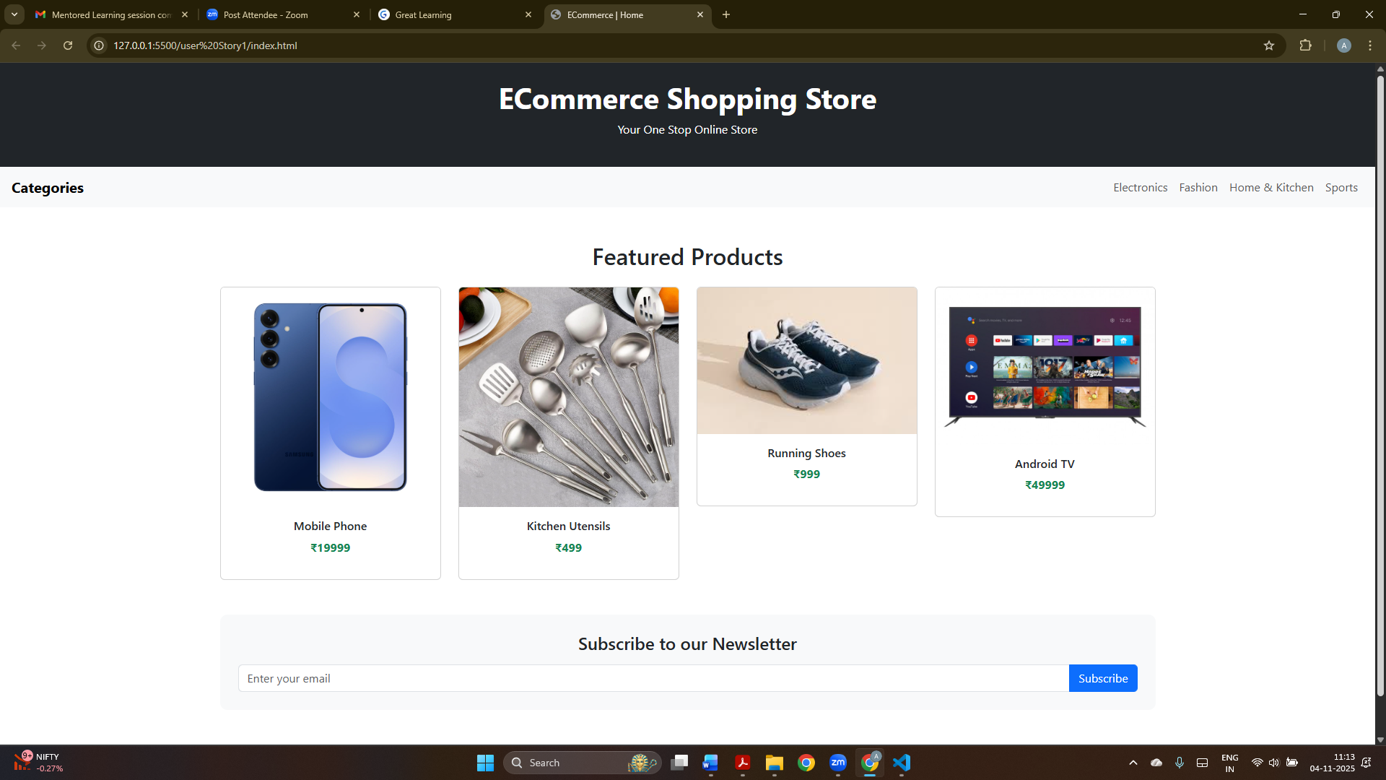
SS 1
The above screenshot displays an Ecommerce Shopping Application with products such as Mobile Phone, Kitchen Utensils, Running shoes and Android TV.

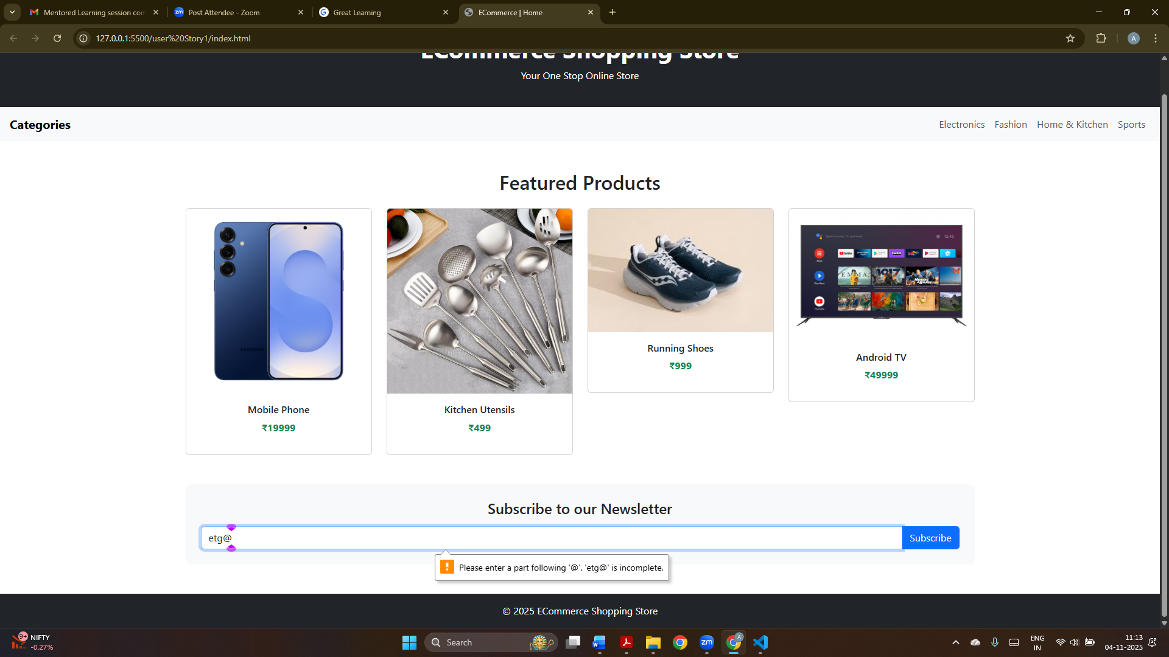SS2
This screenshot displays client-side email validation in a form. When an incorrect email format is entered then an error message is displayed to tell the user to enter the correct email address according to the format for ex. abcd@1234. This is a correct format of email message.

User Story 2
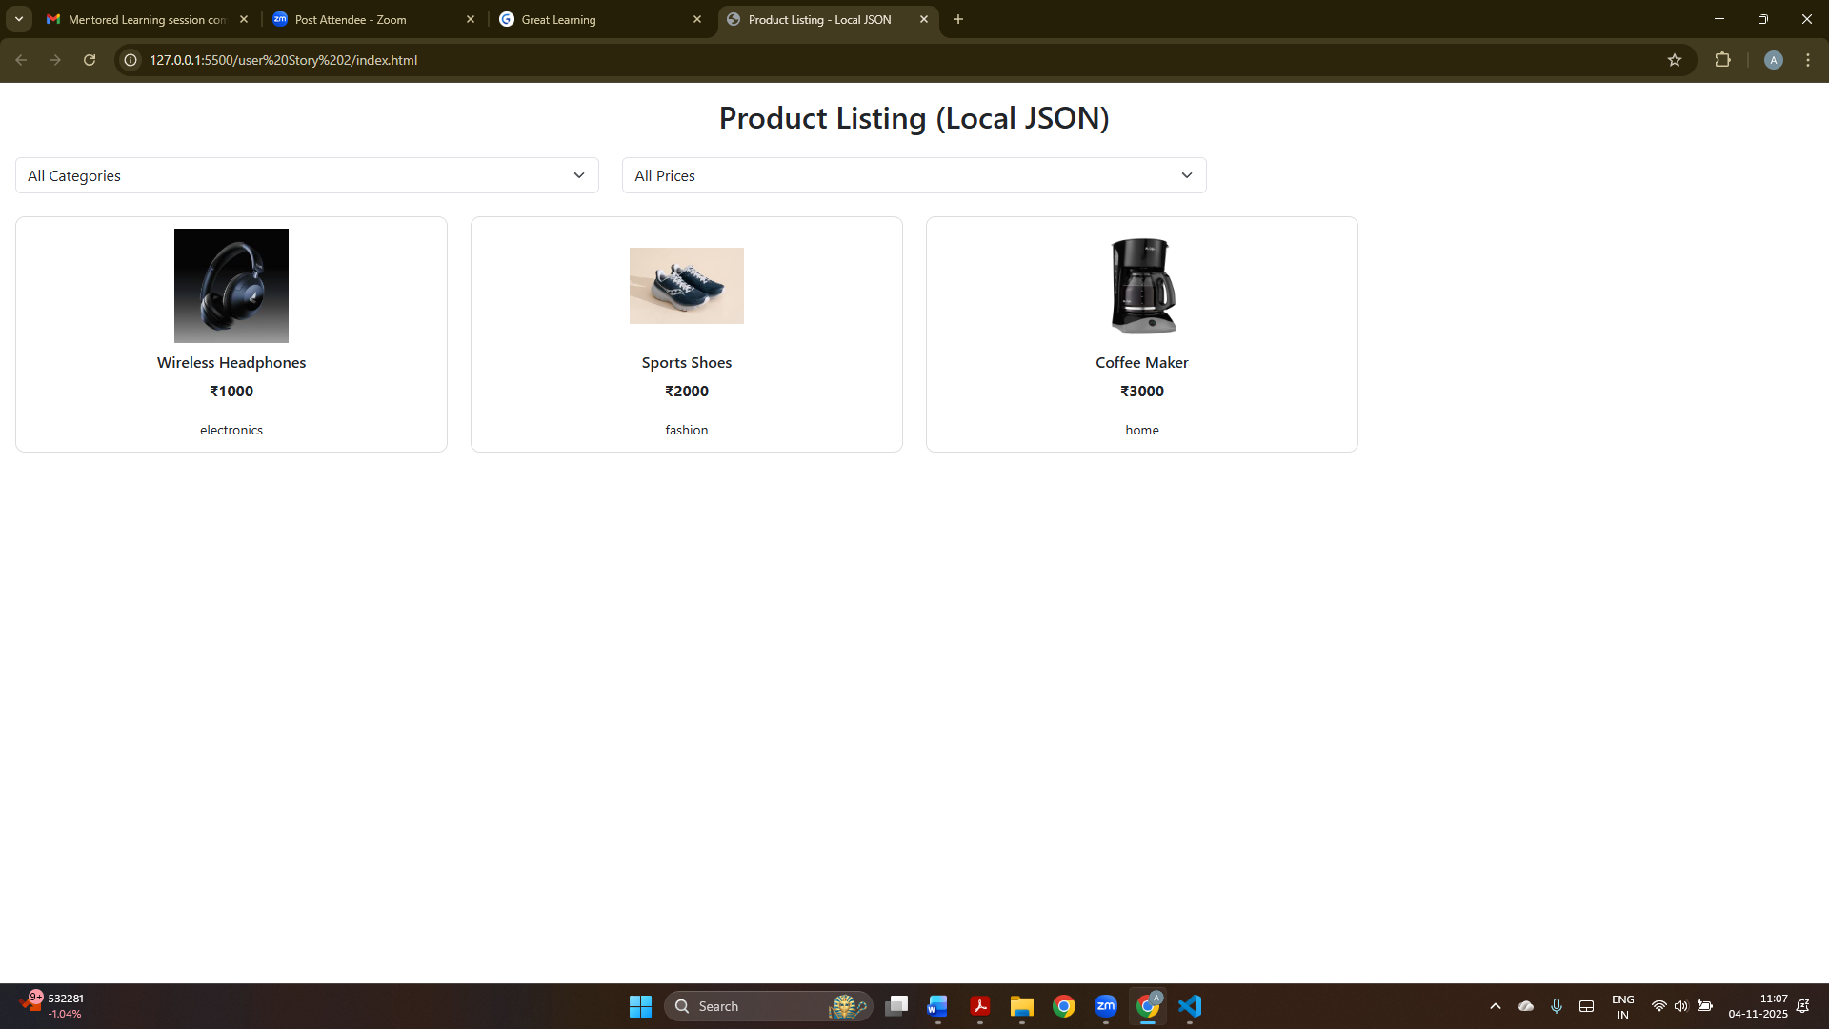
SS 1
This screen shows a product listing page that loads items from a local JSON file.
Users can view products with their name, category, price in rupees, and an image.
Filters at the top allow users to filter products by category and price range.
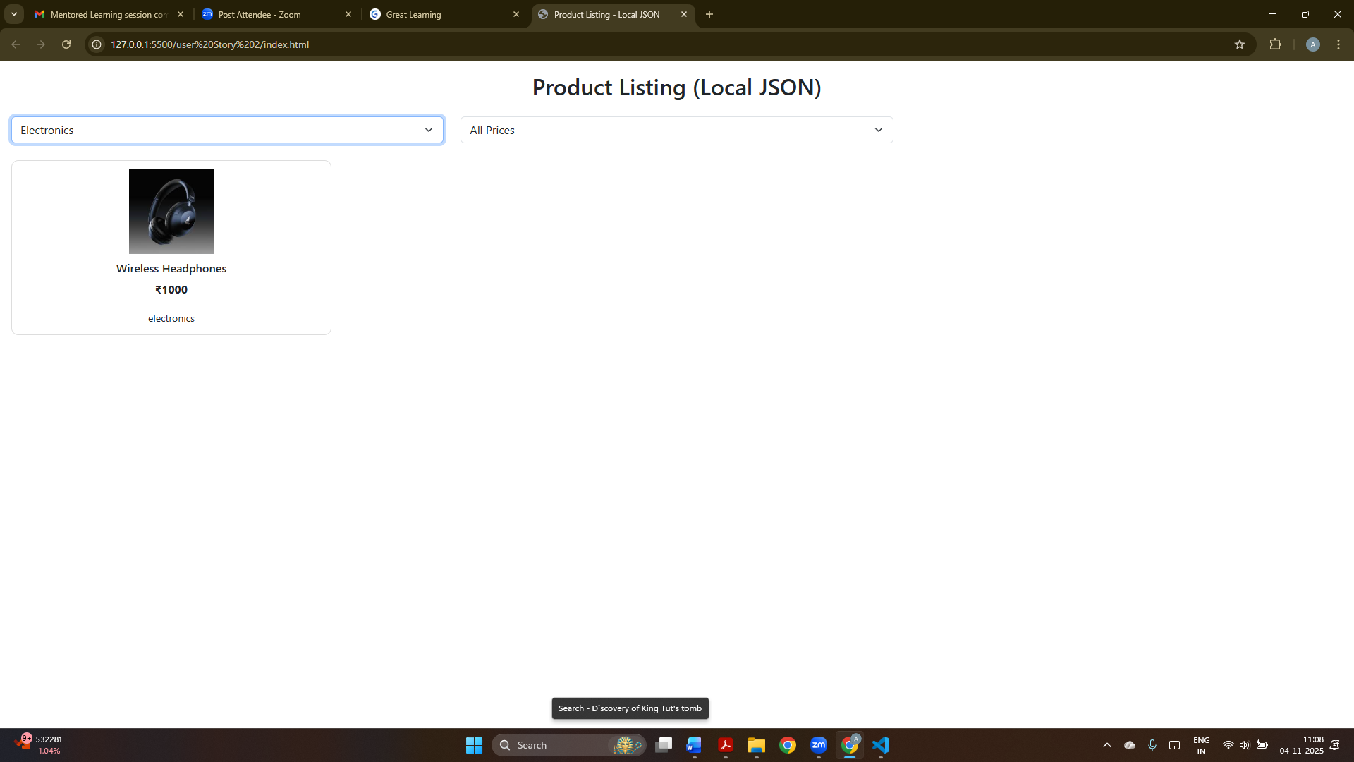
SS2
This screenshot shows product filters such as category and price. Here, I selected Electronics, and the page displays the matching product Wireless Headphones. The filter helps users see only the products they are interested in.

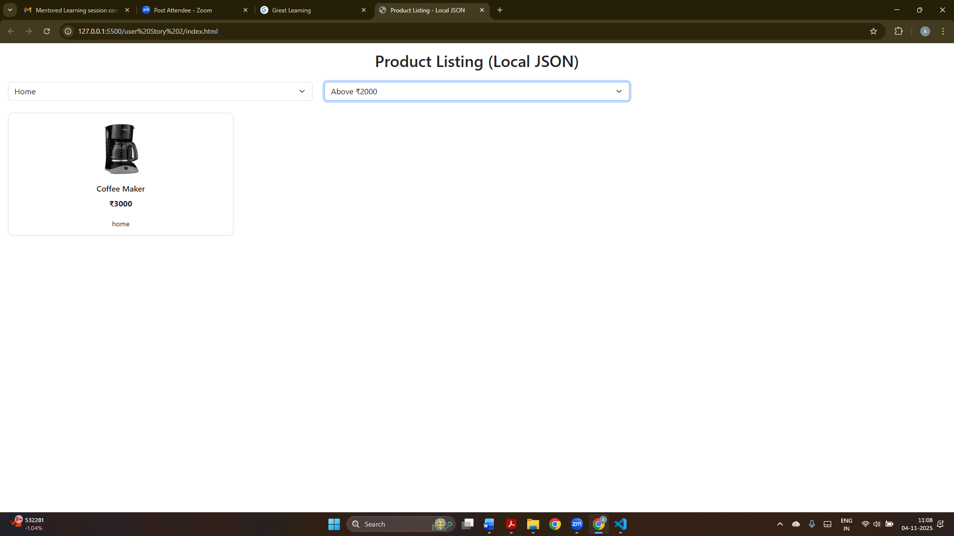
SS 3
This screenshot shows product filters such as category and price. Here, I selected Home and Pricing above Rs 2000, and the page displays the matching product Wireless Headphones. The filter helps users see only the products they are interested in.

User Story 3
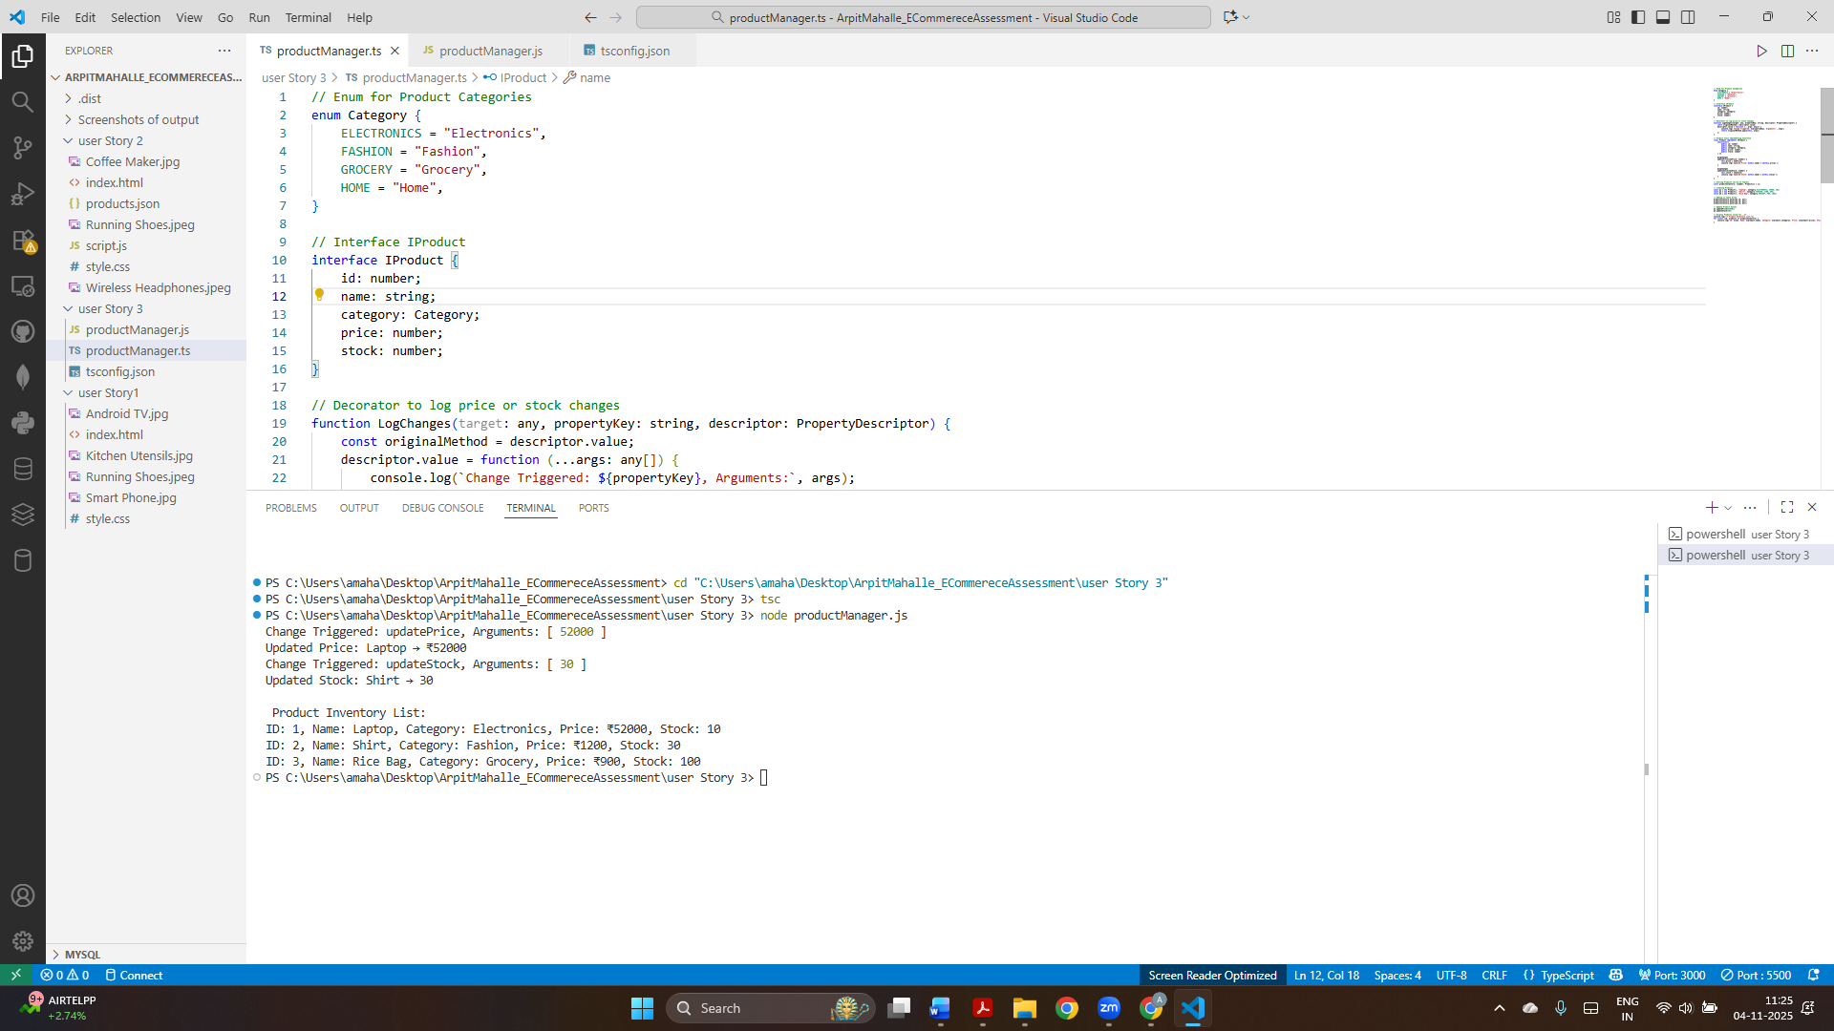
SS 1
This screenshot displays the product management module running in typescript. The console output confirms the price and stock updates were logged using decorators and the inventory list was displayed successfully.
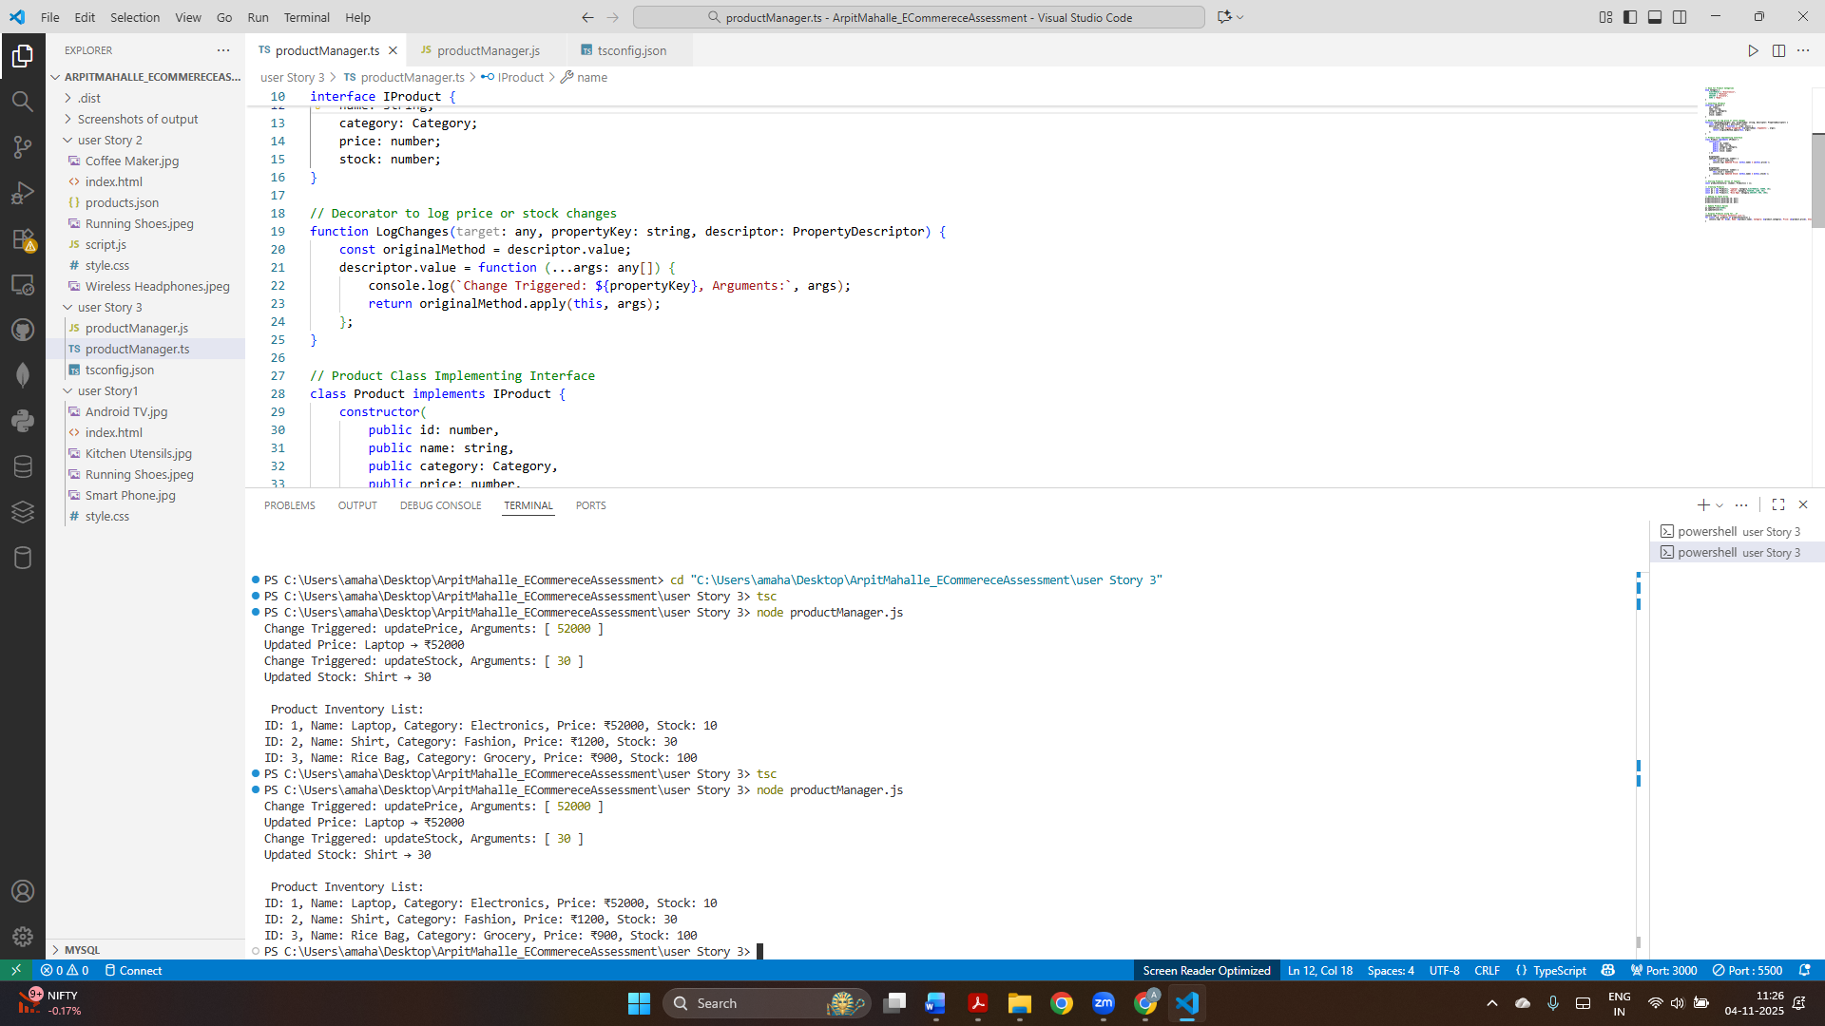
SS 2

